Contact: Rick Scott 310.306.0375
rick@greatscottpr.com

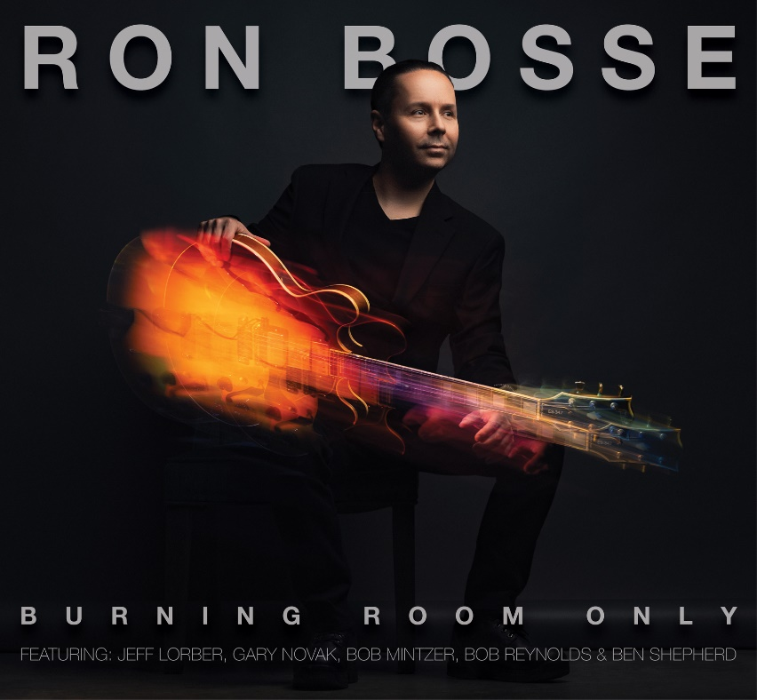

Jazz fusion guitarist Ron Bosse blazes a path via mindset and the power of collaboration

“Burning Room Only,” produced and cowritten by Grammy winner Jeff Lorber, drops October 28.

BOSTON (19 September 2022): Inherently jazz is about collaboration, the sum of the whole being greater than the parts due to the magic that results from improvisation when the chemistry amongst the musicians is right. That’s the approach jazz fusion guitarist Ron Bosse took to record “Burning Room Only.” The Boston-based fretman hooked up with Grammy-winning fusion icon, keyboardist Jeff Lorber, to write and record the eleven-song set produced by Lorber that drops October 28 on the Deep Cat Records label.

Bosse views “Burning Room Only” as a mindset. Yes, musicians love to describe scorching performances as “burning,” and that certainly applies to the masterful musicianship on display throughout this collection, but Bosse takes the meaning deeper.

“On a deeper level, the name is a metaphor for how I feel about people. If you want to be successful in life, you need to surround yourself with people who share the same mindset. In essence, there’s ‘only room’ for positive people who have a ‘burning’ desire to succeed,” said Bosse.

Over the course of fourteen months, Bosse spent hours talking to Lorber about the funky contemporary jazz grooves, intense rock fusion explorations and compelling melodies they were creating. Led by the guitarist’s remarkably proficient and alacritous finger work, the set that Bosse and Lorber crafted is a team effort with this formidable team featuring some real “burners.” Lorber deploys nimble keyboard harmonies and unleashes fiery solos. Drummer Gary Novak (George Benson, Lee Ritenour, Chick Corea) anchors the beats with precision, locking into the bass lines etched by Ben Shepherd, Jimmy Haslip (Yellowjackets), Frenchman Hadrien Feraud, or the colorfully experimental MonoNeon (Prince). Robust horn section arrangements by David Mann add muscle and might, with two saxophonists - the Yellowjackets’ Bob Mintzer and Snarky Puppy’s Bob Reynolds - harnessing soul, power and passion in spotlight solos.

Citing jazz guitar great Pat Martino’s “El Hombre” as inspiration for the groove-jazz style of play that proliferates “Burning Room Only,” Bosse said, “There are two songs on Pat’s album - “Cisco” and “A Blues for Mickey-O” - that are more groove oriented rather than traditional swing, yet Pat still solos with his classic linear approach of fluid eighth-note lines. Ever since hearing that album, I’ve wanted to record an album that was groove oriented, with a contemporary rhythm section, but where the guitar still had a classic clean jazz tone, and the solos were super swinging. With ‘Burning Room Only,’ I think we nailed this approach.”

First out of the gate is the album opener, “Bossman,” which was issued as a single last Friday (September 16).

“My solo on this song really crystallized some of the technical approaches I had been working on for quite some time. I was going for a super streamlined and fluid way of playing eighth-note lines over funky 16th-note-based grooves, and I feel like I really locked in this approach on this song. It definitely set the tone for the solos that followed. Anyone who knows me, knows that I am very dedicated to my instrument in the sense that I’m constantly practicing. In the years leading up to recording this album, and throughout the recording process, I got to a heightened level of practicing of almost 6-8 hours a day. I was really trying to push myself as hard as possible to be able to improvise as fluidly as possible without boundaries with respect to tempo. Essentially, I wanted to be able to play anything that came to my mind and be able to deliver it effortlessly,” said Bosse, who was called “Bossman” by friends when he was a kid.

Tracks from “Burning Room Only” will aptly be promoted at multiple jazz radio formats. Sweetly melodic, invitingly familiar yet grand and challenging in scope, “Kiss The Sky” will begin collecting playlist adds on the smooth side of jazz on September 26.

“To me, the song takes you on a journey through every twist and turn. The melody evolves throughout the song without much repetition, and keeps you closely engaged. The harmony is very complex and enchanting. This was one of the first songs on the album that made me see the true genius behind Jeff’s writing. He has this unique ability to write extremely rich chord progressions, yet he keeps the melody so strong and memorable that you sometimes miss how elaborate it really is. I think that with all art, this is a constant challenge – trying to balance complexity and richness with accessibility,” said Bosse.

Funky with a rock edge that Bosse says reveals his love for Stevie Wonder and Lenny Kravitz, “Rumble Strip” will hit as a second single on October 7.

“This is the first song on the album that we got Snarky Puppy saxophonist Bob Reynolds to play on and I love how he plays on it. His intonation on the melody in unison with the guitar is spot on, and his solo is a great blend of tasteful, bluesy playing combined with some killer jazz lines,” said Bosse admiringly.
Bosse has been playing in jazz bands and leading his own outfits ever since graduating Berklee College of Music. Guitar Player magazine voted him “Outstanding Guitarist,” saying that he’s “a master in the making.” He created the Next Level Jazz concert series in 1998, producing over a hundred shows throughout the US and Canada. Six years later, he founded the Bosse School of Music, a premier pre-college-level program for contemporary music in Weymouth, Massachusetts. In 2007, he launched Bosse Studios, a world-class audio recording and video production studio that produces content for major brands, including Disney, Paramount, Samsung, Amazon, Lockheed Martin, Walmart, Harvard University, NFL, The U.S. Open Tennis Series and many others. Five years ago, Bosse paired up with Grammy-winning R&B-jazz guitarist Norman Brown on a series of duet performances and instructional videos focused on improvisation, technique, composition and production.

Meticulously attentive to details large and small, Bosse poured a lot into making an impactful statement on “Burning Room Only.” And he knew that statement would benefit in ways unimagined via collaboration. In Lorber, Bosse not only found a producer and co-songwriter, but a partner with a shared ethos who is able to coax the best performances possible from the guitarist. Lorber also played a role in surrounding Bosse with the finest musicians available. The chemistry and community formed during the recording sessions elevated the project, forging lasting bonds.

“When I first began the process of recording this album with Jeff, I immediately noticed that we shared similar values in that we feel that all aspects of the production require a high level of attention and detail. Not only is it about the songs, it’s about the orchestration, it’s about the musicians, the solos, the way it’s recorded, how it’s mixed and mastered, the album artwork, the song titles. One of the things I think about when reflecting on the process of writing and recording the album is how collaboration can yield a result far more unique than going it alone, especially if you put the right people together,” Bosse reflected.

“This time period has been one of the most prolific for me which is a true testament to the power of collaboration. My most memorable experience throughout the process of recording this album is the camaraderie and connection with the musicians involved. It’s these personal experiences that really mean the world to me.”

“Burning Room Only” contains the following songs:

“Bossman”
“Power Drive”
“Strutter”
“Checkin’ In”
“Kiss The Sky”
“Rumble Strip”
“Aerodynamic”
“Event Horizon”
“Ante Up”
“DNA”
“Deep Cat”

For more information, please visit www.ronbosse.com.

# # #

